Test 1

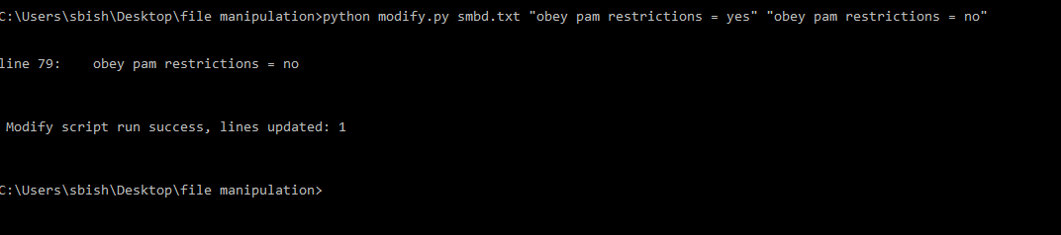

Directory before and After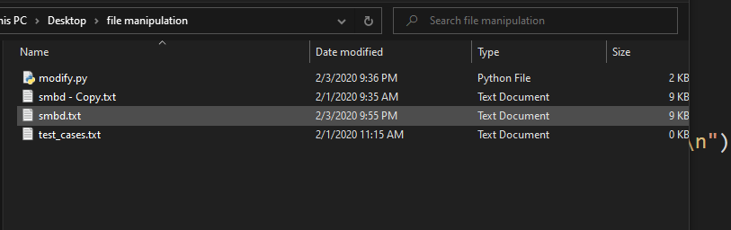

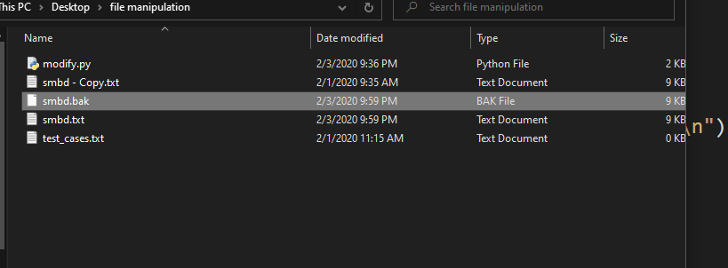

Test 2

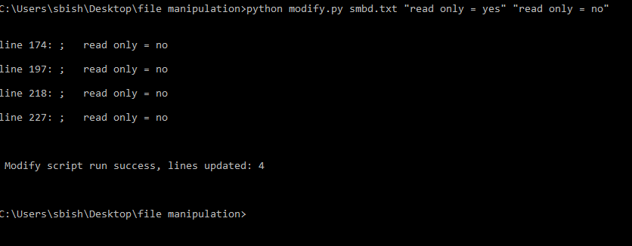

Test for faulty file path

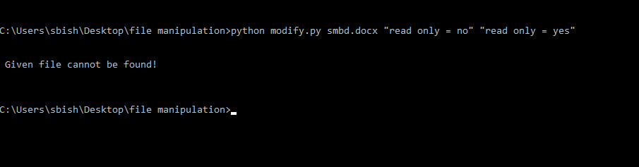

Test for argument quantity error

